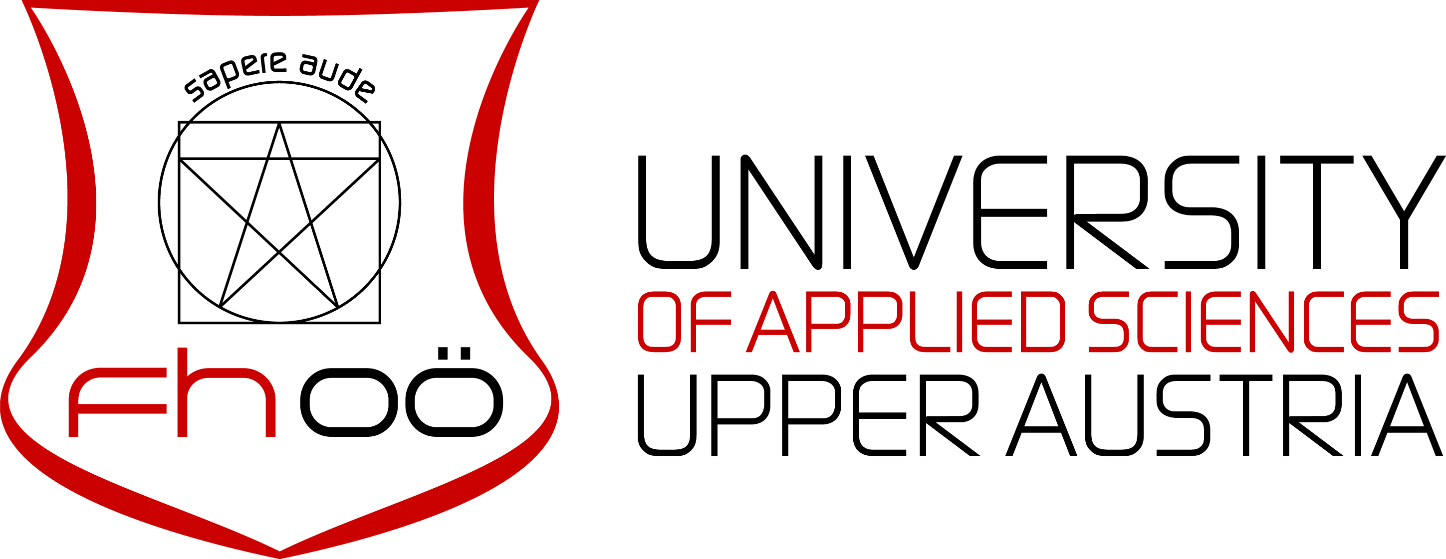
Master’s degree programme
Materials and Process Engineering
Title of your academic work
submitted as a Master Thesis
to obtain the academic degree of
Diplom-Ingenieur/Diplom-Ingenieurin für technisch-wissenschaftliche Berufe (DI oder Dipl.-Ing.)
by
Name
February 2018

Thesis supervisor
FH-Prof. Dr. Name

